Case Study on Statistics

Answer- 1

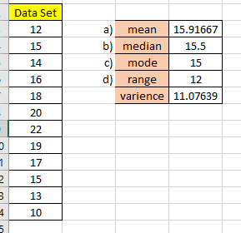According to the given data set, its variance is 11.076 (which is used to understand the spread of data), and the skewness value is 0.072873.

That indicates the given data set is almost have a normal distribution. For calculating range, the maximum value = 22, Minimum value = 10.

Answer -2

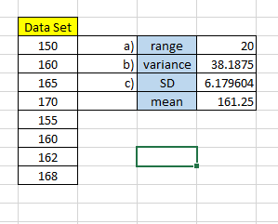Here, the maximum value of the data set is 170, and minimum value-150. Both the variance and standard deviation (SD) are used to describe the spread of data. Variance is expressed in squared units and SD in same unit as the original value.

Answer -3

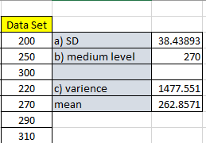

Answer -4

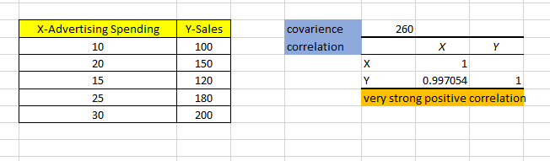

Covariance and correlation are both used to measure the relationship between two variables. Here the covariance value is positive which indicates the variables move in the same direction. And the correlation value is .997 (-1 to +1), it is an extreme value indicating the strong relationship between variables.

Answer -5

b) The correlation coefficient value lies in between -1 to +1, here in the case the coefficient is 1 so it has a perfect positive correlation.

c) IQR is inter quartile range, it indicate the mid spread of the value. It is calculates by finding diffence between upperquartile value and lower quartile value in a data set.

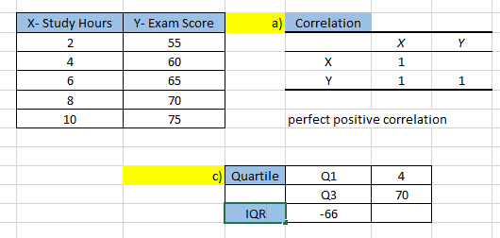

Correlation Graph…………..

Answer -6

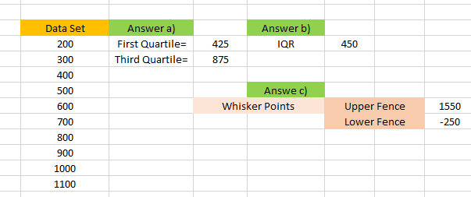

Based on the above given results, there is no outliers in the data set. Because the data included in the upper and lower fences.

Answer -7

1. 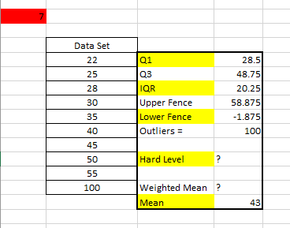in this data outlier value is 100
2. Hard level
3. There is no weights are provided. If we take a particular weight for each one, multiply the each data with corresponding weight and sum the weight and find weighted mean.

Answer – 8

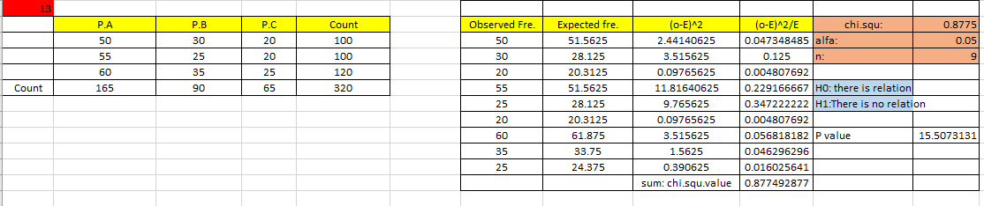

b) Here P value is greater than chi square value. So rejecting the H0. In this data there is f there is a significant difference in customer preferences among the three products.

Answer – 9

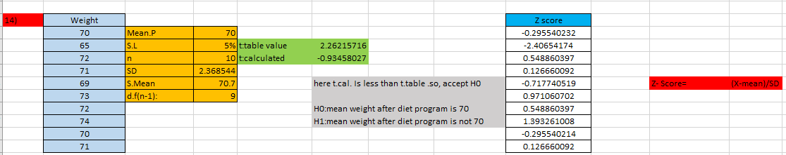

So, it is conclude that the mean weight after program is 70

Answer – 10

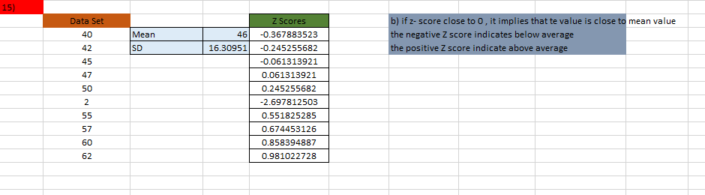

c)

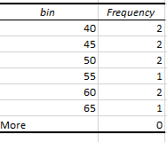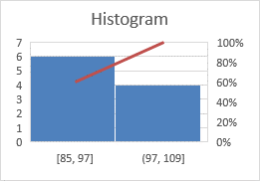

Answer - 11

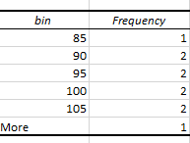

b)

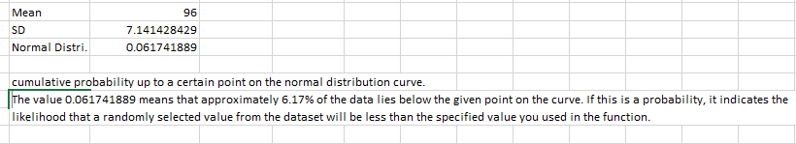

Answer – 12

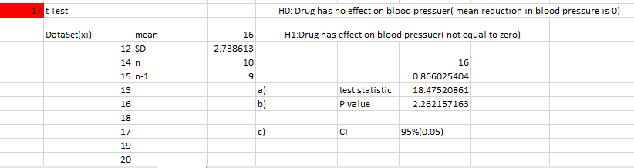

Here, p value (table value) less than the calculated value (test statistic)…..so reject H0

Answer – 13

a)

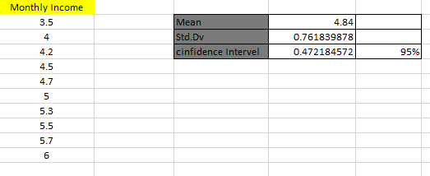

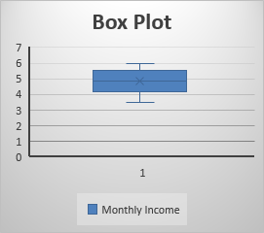b) Box Plot

Answer – 14

a)

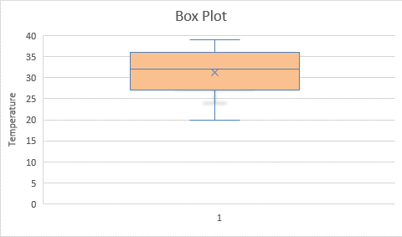

b) 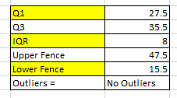

c) Scatter Plot

Answer – 15